GAmeshub Group Assessment rEPORT bY cHRISTOPHER sANDERSON

Table of Contents

Introduction 2

The Team 3

Background description of the app 4

User Analysis 4

General Gamer Statistics 4

User Profile 1 5

User Profile 2 6

User Profile 3 7

App Functionality 8

The Functional Requirements 8

App Design 9

Design Documents 20

Test Cases 21

Coding 22

Recommendations 23

# Introduction

The purpose of this report is to summarize the 10 main areas that allow this app to be created:

1. The team

This introduces the members of the team and gives a description of the tasks that each person in the team has done for the project.

1. Background description of the app

This gives some background information as to why the app has been created for use by the general public.

1. User Analysis

This is to give some statistical analysis as to who in the public domain we are trying to grab the attention of, in this case gamers of any type.

1. App functionality

This describes the functionality that will be essential to the app being able to work properly when it is deployed for use. As well as this it shows the client the functionality of the app.

1. Functional Requirements

Using the descriptions and information given by the three

1. App Design

This involves exploring the color scheme to make sure that the app itself just by its appearance doesn’t make the user want to turn away from it so we have to make sure that the app is attractive to the users.

1. Design Documents

This involves all the design documents that have been used that are essential to the app being able to work and be seen properly when it is deployed for use by the general public.

1. Test Cases and Test Data

This describes the functionality that will be essential to the app being able to work properly when it is deployed for use. As well as this it shows the client the functionality of the app. This will also show how the app will work when any user goes to try the app.

1. Coding

This shows the code that is behind the display that allows the user to be able to use the app effectively.

1. Recommendations

This involves the team in general giving at least 5 recommendations for better practice when working on a project in the future.

These are the key areas that are needed to make sure that the project has gone as smoothly as possible and that the project meets the requirements set at the start.

# The Team

As with any project there are many sections that are essential to making sure that the project works as required. As the project team comprises of five team members who have carried out the specified tasks during the length of the project are:

1. Christopher Sanderson – Requirements Analysis, Font-end Design, Front-end / JavaScript Developer, Report Creator
2. Christine Sarakinis– Back-end developer, App Researcher, Tester, SQL Database Developer
3. Ruby Shakya– Design Documentation(UML), Front-end Developer, Front-end Design
4. Claire King– Project Manager, Back-end Developer, Project Presentation
5. Gerard Gonzalez– Colour Scheme, SQL Developer

# Background description of the app

This app was made and designed with the intent of allowing console orientated gamers to display up to date news regarding console games and also games in general. As with every app there has to be Research done to make sure that the project that is going to be created is feasible or not. So user analysis has to be done before the app can be started.

# User Analysis

### General Gamer Statistics[1]

**Average Age**: 35 years old

**Gender**: 41% female, 59% male

The biggest group of the age of gamers, and thus potential users of this application, is males between the 36 and 50 however the difference between this group and the other groups is not wide enough to design for this specific group. Indeed, the same can be said about the difference between genders: male gamers make up for 54% of gamers, while women make up for 46%.

From these results, the application should be designed to appeal to both male and female, with no specific aim for age.

### User Profile 1



**Name**: David Davis

**Age**: 15

**Employment**: None, high school student.

**Education Level**: In High School

**Computer Literacy**: Moderate. Has a good working knowledge, grown up using computers and can solve minor problems but any major issues may be out of his league.

**Gaming Behaviour**: Mainly playing online games with his friends. Plays mainly Call of Duty and Destiny. He also plays games such as Skyrim, Assassin’s Creed but always goes back to playing his multiplayer PvP (Player Versus Player) games.

**Device usage**: Both Mobile and Desktop computer, mostly Mobile.

**Reason for Use**: Likes to keep track of the yearly games such as Call of Duty and Assassin’s Creed, as well as the big games that catch his eye.

### User Profile 2



**Name**: Annie Anderson

**Age**: 30

**Employment**: Retail Worker

**Education Level**: College Graduate

**Computer Literacy**: High, can navigate websites easily, and only the more complicated bugs will be a problem for her.

**Gaming Behaviour**: A big gamer, she like to always have a game that she is playing through

**Device usage**: Both Mobile and Desktop computer, mostly Mobile.

**Reason for Use**: Look through the games that are upcoming and mark some for her attention so that if any new information is release about any of the games that she is interested in come up she will know quickly.

### User Profile 3

**Name**: Bob Robertson

**Age**: 50

**Employment**: Electrician

**Education Level**: In High School

**Computer Literacy**: Average. Doesn’t use computers very often. He has a smartphone but games exclusively on gaming consoles. If and errors or bugs come up he is likely unable to work around them and will leave the site, however excluding bugs he can navigate all but the more complicated sites.

**Gaming Behaviour**: Plays games that are larger games, the more critically acclaimed ones. He plays in small sessions at every few nights.

**Device usage**: Very rarely uses desktop computers. He mainly uses his smartphone, and his PS4 for gaming.

**Reason for Use**: Likes to keep up with the release dates of upcoming games, and where he can find the best price for the games he is interested in.

# App Functionality

Once the team have had a brief containing the idea created and reassured to them, then there has to be a look at what the requirements are of the app and what type of functionality the app will have exactly.

Here is a list of the pages, with descriptions of what will be on those pages, that will be created for the app GamesHub.

* Members log-in area - add, remove, look through favs.
* Home page - non-member w/all news. Member section has favourites.
* Select Favourites to follow game news
* Use feed to gather info for the site
* Feedback section - link to a form page? General comments page?
* Search functionality
* Categories? - depends on feed. Maybe by console? By genre?

# The Functional Requirements

From gathering the information of what the pages are and how they are required to function, the requirements for the system, app and users can be easily defined and created. There are two types of requirements, functional (these are required for the app to work) or non- functional (these aren’t required for the app to work). Functional requirements mean that they have to be split up into certain sections, in this case the functional requirements are split up into four groups: Super-Admins, Admins, general users and the system.

Functional requirements

Super-Admin – these users have the same powers as the usual admins but they control who uses the system and allows promotions for the roles the registered users have:

1. Log in and out
2. View feeds if logged in or not
3. Create an account
4. View multiple feeds if it is required
5. Add comments and send feedback to developers
6. Add feed to favourites if logged in
7. Remove feed from favourites if logged in
8. View favourites if logged in
9. Search for categories
10. Check feeds depending on how they are stored (console or genre)
11. View separate feeds if logged in
12. Log in to multiple devices
13. Add posts to the database
14. Remove posts from the database
15. Add users to the database
16. Remove users from the database
17. Promote users to admins or super-admins

Admin– these users have the same as any general/registered user but they can create the posts that the users can see when they open the app:

1. Log in and out
2. View feeds if logged in or not
3. Create an account
4. View multiple feeds if it is required
5. Add comments and send feedback to developers
6. Add feed to favourites if logged in
7. Remove feed from favourites if logged in
8. View favourites if logged in
9. Search for categories
10. Check feeds depending on how they are stored (console or genre)
11. View separate feeds if logged in
12. Log in to multiple devices
13. Add posts to the database
14. Remove posts from the database
15. Add users to the database
16. Remove users from the database

Users – these users can only view the posts that have been created by the admin/super-admin:

1. Log in and out
2. View feeds if logged in or not
3. Create an account
4. View multiple feeds if it is required
5. Add comments and send feedback to developers
6. Add feed to favourites if logged in
7. Remove feed from favourites if logged in
8. View favourites if logged in
9. Search for posts
10. Check feeds depending on how they are stored (console or genre)
11. View separate feeds if logged in
12. Log in to multiple devices

System must be able to:

1. Connect to feeds and display them on the app
2. Add posts to the database
3. Remove posts from the database
4. Add users to the database
5. Remove users from the database

Non-functional requirements

1. Adding notifications for logged in users
2. Adding feedback option for any user for developers
3. Colour Scheme must be the same
4. Layout must be the same for every page

# App Design

**DESIGN**

**Colours**

**The importance of colors in apps development**

The colors of an app are of vital importance as each color, or combination of colors, causes different feelings and emotional reactions to the user. Therefore, depending on the theme of your application or the feeling that you want to provoke at user will be more convenient to use some colors or others.

**Color theory for designers**

In the visual arts, color theoryis a body of practical guidance to color mixing and the visual effects of a specific color combination.

We will not go into details about it in this document, but it is important to consider it for the development of our mobile application.

**Color Psychology: How colors affect us and what each one means**

We must keep in mind that one color can represent totally different things in different cultures, so it may not trigger the same sensations for everybody around the world.

For example, white color usually represents purity, peace, luminosity. In fact, in many countries wedding dresses are usually white. However, in India and other Eastern countries, white is the color of mourning and women dress in orange or red on their wedding day, colors that represent prosperity and fertility for them.

In the same way, a color can cause totally different reactions if we vary the hue or saturation.

The study of colors and their influence on the human brain is very extensive. For this reason we give only a summary of some of its meanings.

**Red: Passion, Love, Wrath**

Invites action, to do something, opens the appetite, symbolizes passion and love, etc.

Invites to be impulsive because it creates a sense of urgency.

Its extent and intensity must be controlled due to its excitation power. In large areas it can tire easily.

**Orange: Energy, Happiness, Vitality**

Denotes excitement and enthusiasm, which is why its use is limited to calls to action and generate impulsive buying opportunities. But always being reliable.

**Yellow: Happiness, Hope, Deception**

Usually represents happiness and brings optimism. Yellow color is linked with intelligence and creativity as it stimulates mental activity and feelings of happiness. It acts as a tranquilizer for certain states of nervous excitement. It is a warm color and generate good vibes and joy. It is the color of light, sun, action, power, strength…

It also has a negative meaning like laziness, arrogance and envy.

**Verde: New beginnings, Abundance, Nature**

Associated with nature, tranquility and health. Although associated with wealth and symbolizing money, it is used in marketing to calm the customer.

It is a useful color for web design related to the environment.

**Azul:** **Calm, Responsibility, Sadness**

Brings serenity and peace to the client/user, increases productivity. Creates a sense of security and confidence.

It can have a negative meaning like depression or indifference.

**Purple:** **Creativity, Royalty, Wealth**

It acts directly to the heart. It suggests abundance, sophistication, intelligence, spirituality, religiosity, dignity. But it can also evoke frivolity, artificiality and pomposity.It represents mystery, ceremony, enlightenment, telepathy, empathy. Ideal color for web designs aimed at a female audience.

**Black:** **Mystery, Elegance, Evil**

It is related to darkness, pain, despair, formality, sadness, melancholy, unhappiness, anger and the dark. It is a color that denotes power, mystery and style. In web design can give image of elegance and sophistication and increases the sense of depth and perspective.

**Pink: Charm, Courtesy, Tenderness**

Used for romance and feminine presence because it suggests calm and tranquility, very useful to create a relaxed atmosphere. It means spring, gifts, appreciation, admiration, sympathy, health, love, june …

**Brown:** **Nature, Healthy, Reliability**

It symbolizes friendship, earth, materialistic thinking, reliability, peace, productivity and practical work. It represents old age, has connotations of quality, comfort, conservative and natural.

White: **Purity, Cleanliness, Virtue**

It symbolizes purity, faith, peace, joy and neatness. It is considered the color of perfection. It is associated with freshness and cleanliness because it is the color of snow. Useful to show or highlight other colors and give the impression of simplicity and clean. It has negative meaning as cold and distant color.

**Gray: Bad mood, Conservatism, Formality**

It is linked to the elegant, fresh, innovative, modern, futuristic, technological, spacious, soft, neutral. It can represent respect, grief, boredom and old age. It is a color that helps to highlight the other colors.

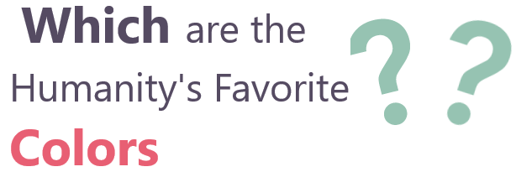

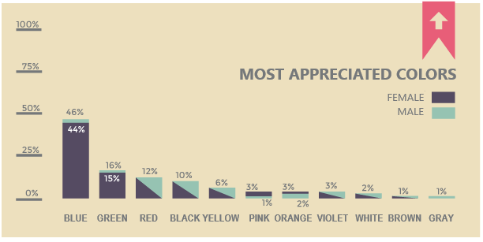

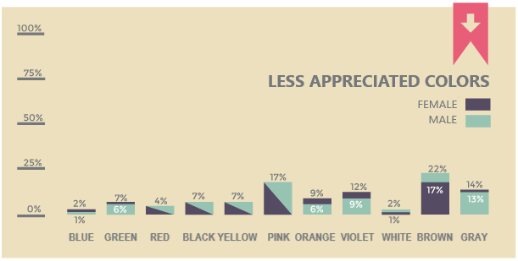

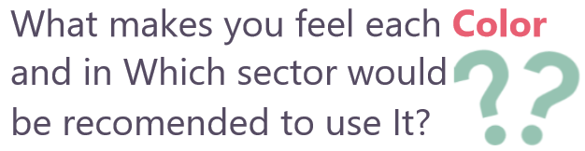

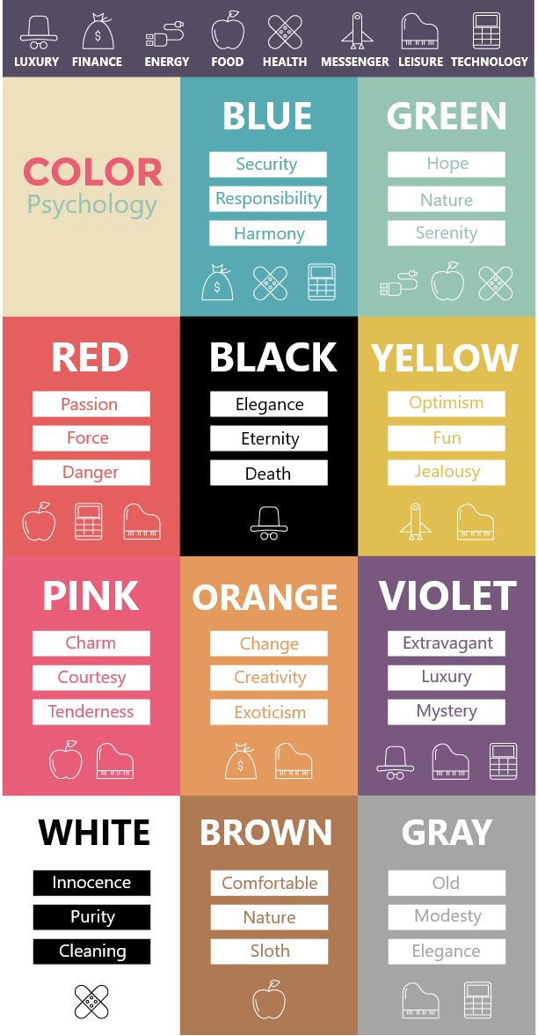

**Other important aspects**

One aspect that usually not have in consideration is that ***almost 9% of population suffers color blindness***. This disease directly affects the ability to distinguish some colors from one another.

We must take it into consideration when implementing our designs to make our application more accessible.

**Our choice: Colors and reasons**

Some suggestions..

   

More…

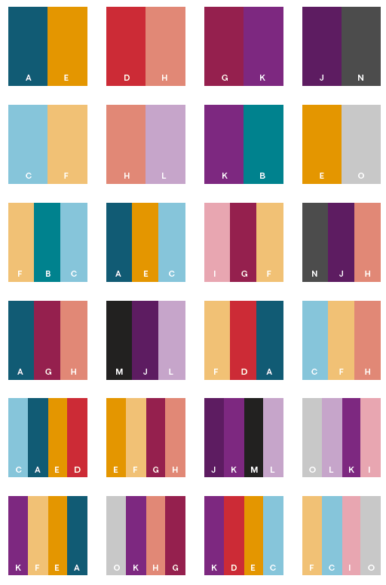

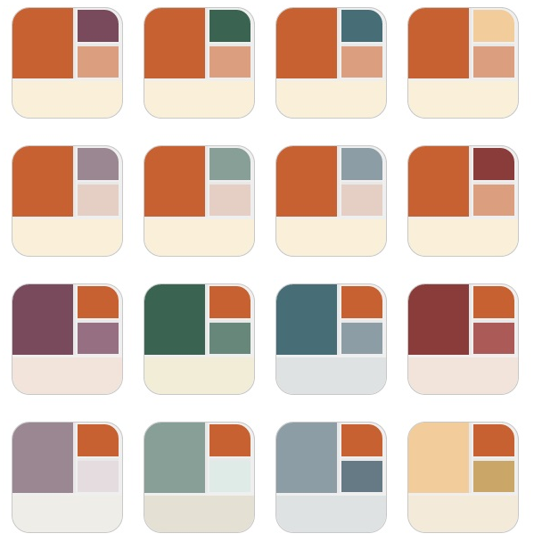

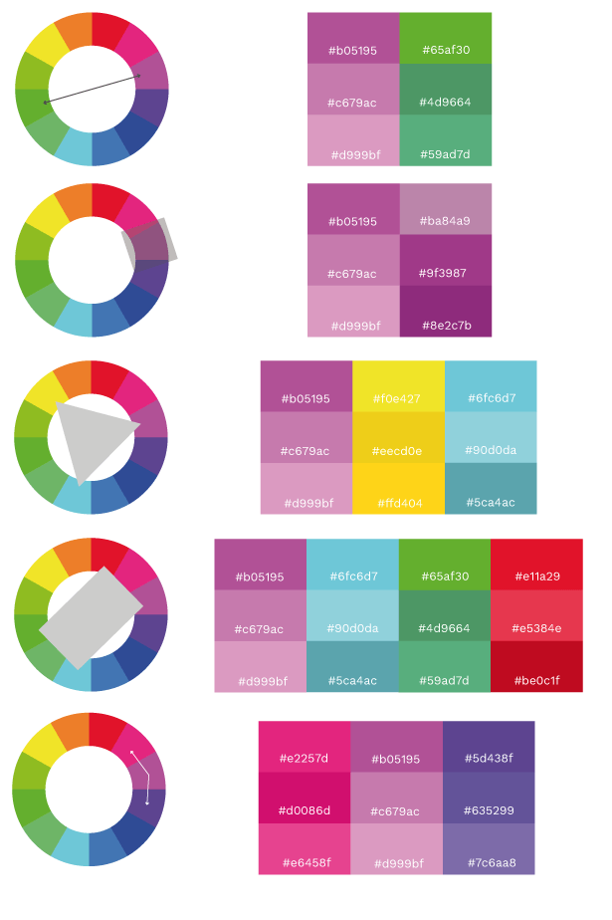

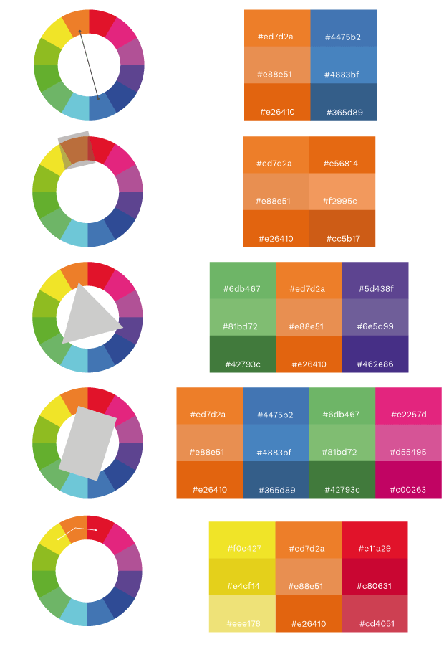

What do you think?????

**Logo**

The logo is a very important part of design as it is the face that represents the brand.

WHAT LOGO?????

**Wireframes / Prototypes**

**HOME**

# Design Documents

# Test Cases

# Coding

# Recommendations

Here are some recommendations made by the group that can be used and put into practice when the group are next involved with this project

1. Adding in the functionality for a feedback page so that users can contact the developers with any type of question or statement.
2. Creating a page for users to edit their own details in case any of these details have change that they already have submitted to the app’s database.
3. Allowing a section that allows the users to view the prices and places where the games are in stock to be displayed. As this will help users decide where they are going to go and purchase the game/games.

1. The Association of UK Interactive Entertainment(20 August 2017), UK Video Games Fact Sheet, [Online]https://ukie.org.uk/sites/default/files/UK%20Games%20Industry%20Fact%20Sheet%2010%20August%202017.pdf [Accessed: 1 October 2017]